March 9th, 2021

Excel Homework: Kickstart My Chart

1. Given the provided data, what are three conclusions we can draw about Kickstarter campaigns?
   * 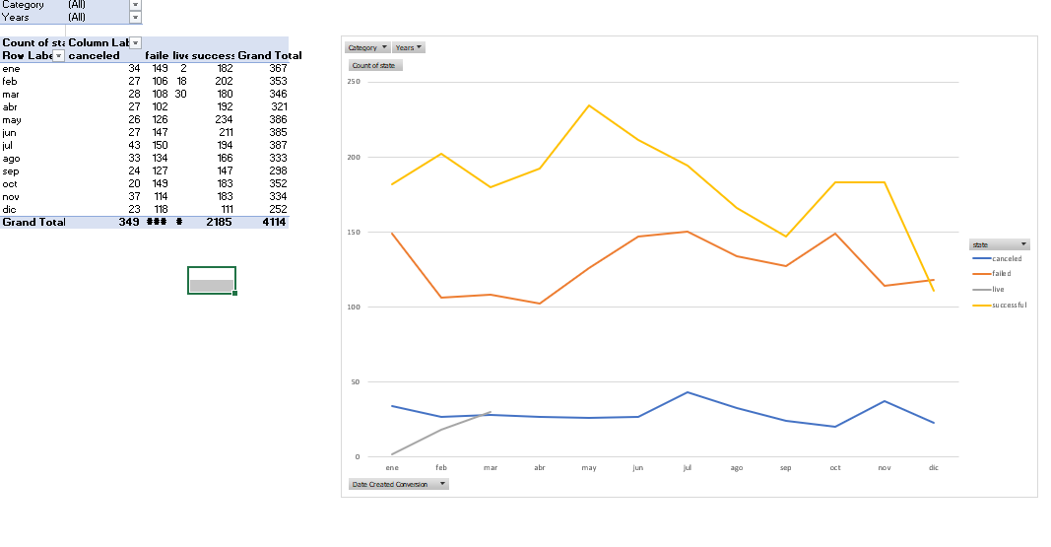When the goal is higher has a high probability to be failed or canceled
   * Ten subcategories represent 80% of total successful campaigns

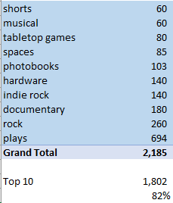

* + Three countries represent 95% of total successful campaigns. Just US represents 76% of total successful campaigns.

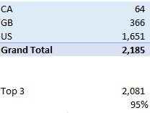

1. What are some limitations of this dataset?
   * Currency: You will need to convert to one currency unit to measure in a more consistent way.

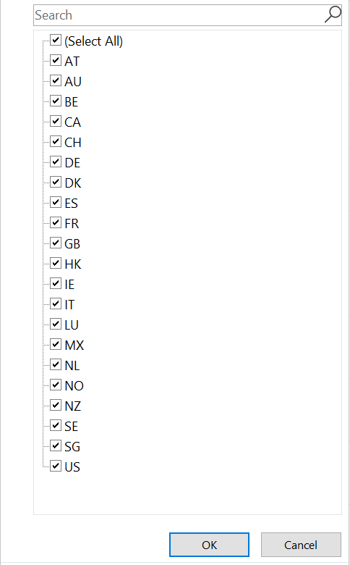

* + Difference between Date Ended and Date Created: You will need to weight the results because the duration of campaigns does not have the same time. Goes from one day to 90 days

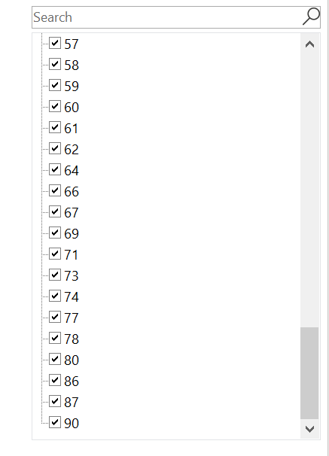

1. What are some other possible tables and/or graphs that we could create?
   * Growth rate YoY since 2009-2017 (Categories or Countries)
   * Map by country and using Pies for categories/sub categories
   * Bubble Charts (US will dominate the size of this bubble)